22

Managing Object-Oriented Projects
Objectives
In this chapter you will learn:
- how to manage iterative projects;
- how to use project planning techniques;
- about metrics for object-oriented projects.

22.1 Introduction
Information systems development is a complex activity that requires careful project management. There are inter-dependencies between the artefacts of software development, and their production has to be planned, monitored and co-ordinated if software development is to be efficient, effective and the project completed to deadline. A large software development project may involve many developers, some with specialized skills, who will be required at different times during the project. For example, the specialist in requirements capture is required early in the project, the expert in ODBMS implementation is needed during design and construction, the installation and support teams become involved to some extent during design and construction and more fully when the information system is complete. These different activities may require different resources whose availability has to be planned. Project management is further complicated as some activities must follow a particular sequence. For example, testing a system can only begin when at least some elements have been constructed though of course, test scripts and test harnesses may be prepared earlier in the project. Many object-oriented development approaches involve iteration and this presents particular challenges: one key issue is how to control the number of iterations.
Many factors affect the length of time that it takes to complete a given activity and it is not possible to quantify them all. Some factors are measurable (at least to some extent), for example, project risk, system size and complexity. Less tangible aspects of the project such as staff expertise, team morale or the difficulty of using new technology are harder to measure.
Software patterns that were introduced in Chapter 8 related to analysis and those discussed in Chapter 15 are mainly useful in a design context. Other patterns have been identified that are applicable to the management of the development process.
The move towards object-orientation introduces a series of challenges for an organization. One of the difficulties of introducing object-oriented development to an organization is that, initially at least, some systems are based on an object-oriented approach while others are not. Staff must be trained, and existing software systems must be integrated with the new approach. Any major change, and a change in development method is only one example, requires careful planning in order to minimize the attendant risks.

22.2 Resource Allocation and Planning
Given the complexity of project management there is a need for tools and techniques to support the process. Yourdon (1989) identifies three particular areas of the management of software development where modelling techniques can play a useful role:
- in the estimation of money, time and people required;
- in assisting the revision of these estimates as a project continues;
- in helping to track and manage the tasks and activities carried out by a team of software developers.
Many tools (e.g. CA-SuperProject, MS Project) have been developed to support the management of any type of project, not just those that are focused on software development.

22.2.1 Critical Path Analysis
The technique known as Critical Path Analysis (CPA) was developed in the late 1950s for use on major weapons development projects for the US Navy (Whitten, Bentley and Barlow, 1994). Originally known as Project (or Program) Evaluation and Review Technique (PERT), it is also called Network Analysis and it has been widely used on many different types of project.
For the purposes of carrying out a critical path analysis, a project is viewed as a set of activities or tasks, each of which has an expected duration. Completion of an activity corresponds to a milestone or event for the project. Each milestone also represents the start of activities that are directly dependent on the completion of the predecessor or predecessors. CPA is based on an analysis of sequential dependencies among the activities, and uses the expected duration for each task to derive an estimate of the overall duration of the project. In particular, it identifies any inter-task dependencies that are critical to the project duration—collectively these are known as the critical path. The preparation of a CPA chart involves the following steps.

List all project activities and milestones
A sample list for the development of the Agate Campaign Management system is shown in Figure 22.1. Each activity is labelled with a letter and has a short description. The third column in the table contains a milestone number that represents the completion of that activity. Note that milestone 1 represents the beginning of the project.

Activity | Description | Milestone | Preceding activities | Expected duration | Staffing
A | Interview users | 2 | - | 3 | 2
B | Prepare use cases | 3 | A | 2 | See A
C | Review use cases | 4 | B | 2 | 3
D | Draft screen layouts | 5 | C | 2 | 2
E | Review screens | 6 | D | 2 | 2
F | Identify classes | 7 | C | 2 | 3
G | CRC analysis | 8 | F | 4 | 3
H | Prepare draft class diagram | 9 | F | 5 | 3
I | Review class diagram | 10 | E, G, H | 4 | 4
Figure 22.1 Project activity table for Agate.

Determine the dependencies among the activities
Some activities cannot start until another (sometimes more than one) has been completed. The preceding activities are listed in column 4. For example, in Figure 22.1 the activity Review use cases must be completed before the activity Identify classes can begin.

Estimate the duration of each activity
There are several different approaches to this, due to the uncertainty involved in estimating task duration. One that is used widely is given by the following formula:
ED = MOT + (4 × MLT) + MPT
6
where ED is the expected duration of a task, MOT is the most optimistic time, MLT is the most likely time and MPT is the most pessimistic time for its completion. The ED is thus a weighted average of the three estimates. Each MOT assumes that a task will not be delayed, even by likely events such as employee absence. The MPT assumes that most things that can go wrong will go wrong, and that completion of the activity will be delayed to the maximum plausible extent. Equipment will arrive late, technical problems will occur and some staff will be ill. (It would be unrealistic to take this to the extreme, for example, to assume that all development staff will be struck down by an influenza epidemic—estimates should be realistic.) The EDs are entered in the fifth column of the table. Note that in this example the staff requirements for activities A and B have been treated as one since the two activities are highly interdependent. These two activities could be combined into a single activity called Interview users and prepare use cases.

Draw the CPA chart
Two main styles of notation are used for CPA charts, known respectively as ‘activity on the node’ and ‘activity on the arrow’ diagrams. Both show the same information, but they look very different from each other. First we present the ‘activity on the arrow’ notation and then show an example of the alternative style in Figure 22.8. In the ‘activity on the arrow’ style each milestone is represented by a circle divided into three compartments as shown in Figure 22.2. One compartment is labelled with the milestone number, and the other two will hold the earliest start time (EST) and the latest start time (LST) (these terms are explained below) for all activities that begin at that milestone.
The first draft of a CPA chart shows dependencies between activities and their expected durations, since this information is known or can be estimated before the diagram is drawn. The partially completed CPA chart in Figure 22.3 represents graphically the activity precedences listed in table form in Figure 22.1.Note the dummy activity between milestones 8 and 9 (and also between 6 and 10). The explanation for this is that activities H and G both depend on milestone 7 (the completion of activity F), and are also both predecessors to milestone 9 (where activity I begins). Since H and G may not necessarily finish at the same time, an extra milestone is needed for one of these events. In effect, milestone 8 represents the completion of G, regardless of whether or not H has finished (it is not significant which of the two activities is chosen to terminate at the extra milestone). A dummy activity (with estimated duration of 0) then needs to be introduced in order to connect milestone 8 to milestone 9, thus preserving the sequence of dependencies.
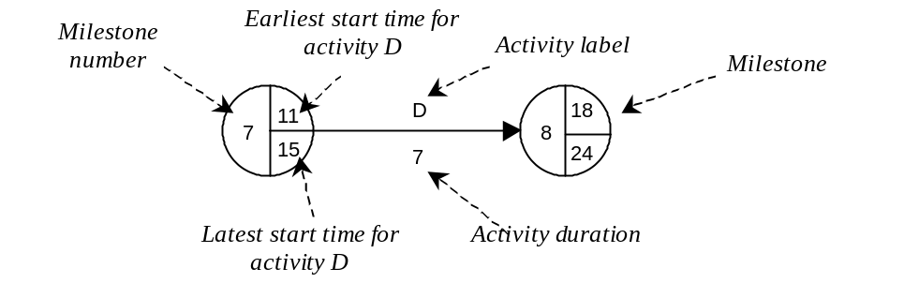
Figure 22.2 CPA notation.

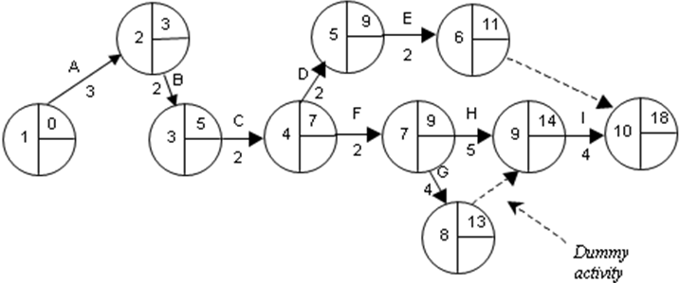
Figure 22.3 Partial CPA chart for the Agate advertising sub-system project.

The next step is to enter an earliest start time (EST) for each milestone. This is done by working through the diagram from the very first milestone to the very last (sometimes called a forward pass). It is a convention that the EST for the first milestone is set to 0 (elapsed time is usually measured in days, but any other unit of time can be used equally well). The EST for most other milestones is calculated simply by adding the EST of the immediately preceding activity to its duration. For example, activity C (the immediate predecessor for D) has an EST of 5 and an ED of 2, therefore the EST for activity D is 7. Where an activity has two or more predecessors, its EST is determined by the predecessor that has the latest completion time. For example, activity I is dependent upon the completion of both G and H, so its EST is set to the later of the two calculations. In general the EST for any milestone is set to the earliest time that all predecessor activities can be completed.
The next step requires completing the latest start time (LST) for each milestone. The latest start time is entered by working back from the last milestone (sometimes this is called a backward pass). The LST for the last milestone is set equal to its EST. Each preceding LST is then calculated as follows. The LST for most milestones equals the LST for its successor minus the ED of the intervening activity. For example, the LST for milestone 9 is 18 − 4 = 14 (the LST for milestone 10 minus the ED for activity I). Milestone 7 presents more of a problem as this has two successor activities, G and H. In such cases, two calculations are performed (or more, if there are more than two successors) and the earlier of the two answers is taken. For example, if the LST for milestone 7 were determined purely by activity G, this would give 14 − 4 = 10 (the LST for milestone 8 is 14 because the dummy activity has duration 0). This means that activity G can afford to begin as late as time 10 without delaying any other activities. But a similar calculation for activity H gives 14 − 5 = 9. This means that if H begins later than time 9, its completion will be delayed beyond time 14, which in turn would delay milestones 9 and 10 and thus also activity I and the project completion. The LST for milestone 7 is therefore set to 9. In general, the LST for a milestone is set to the latest time that allows every activity that begins at that milestone to be completed by the LST for its succeeding milestone. The LST for milestone 8 is 14, the same as milestone 9, because the dummy activity has duration 0.
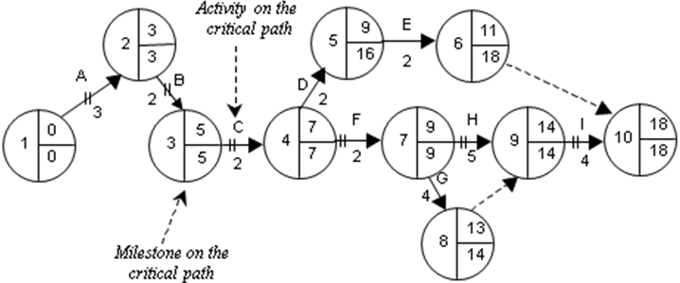
Figure 22.4 The critical path for the Agate advertising sub-system project.

Identify critical path
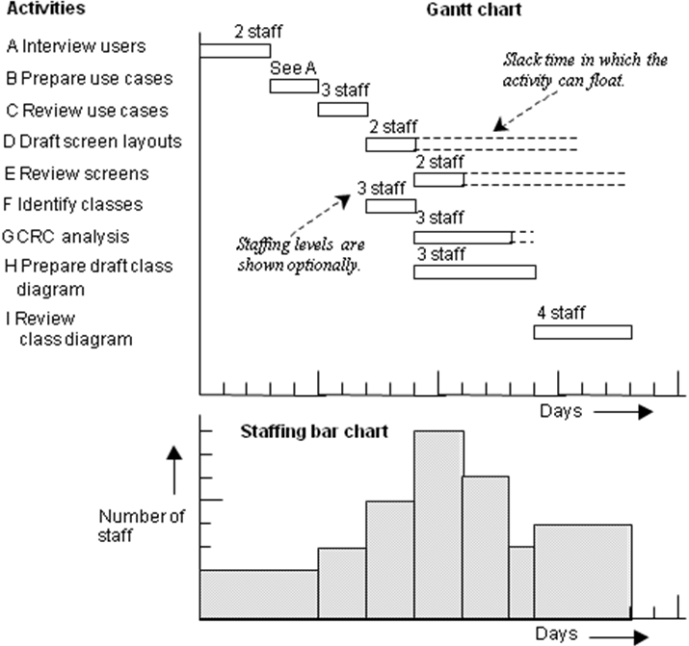
Figure 22.5 Gantt chart with staffing bar chart.

Once all LSTs have been entered onto the diagram, the slack time (or float) for each activity can be calculated. This is the difference between an activity’s EST and its LST, and it represents the time by which that particular activity can be delayed without affecting the overall duration of the project. The path through all milestones that have a slack time of 0 is called the critical path. This is indicated by a double bar across activity arrows that connect the milestones. These milestones, and their intervening activities, are critical to the completion of the project on time. Milestones that have an EST that is different from their LST are not critical in the sense that they have some scheduling flexibility. The completed diagram is shown in Figure 22.4.
A CPA chart is an effective tool for identifying those activities whose completion is critical to the completion of a project on time. If any activity that is on the critical path falls behind schedule then the project as a whole is behind schedule. However, while critical activities naturally receive the closest scrutiny, all project activities should be monitored. Delay even in a non-critical activity can, if it is sufficiently severe, alter the critical path.
CPA charts have limitations, chief among which is that they are not very useful for representing the extent of any overlap between activities. As a result, they are often used in conjunction with other techniques, particularly the Gantt chart (described in the following section).

22.2.2 Gantt charts
The Gantt chart (named for its inventor Henry Gantt) is a simple time-charting technique that uses horizontal bars to represent project activities. The horizontal axis represents time and is often labelled with dates or week numbers so that the completion of each activity can be monitored easily. Activities are listed vertically on the left of the chart, and the length of the bar for each activity corresponds to its ED.
A Gantt chart shows the overlap of activities clearly and this provides an effective way of considering alternative resource allocations. The Gantt chart can be drawn with either dashed lines or dashed boxes that show the slack time for non-critical activities.
A Gantt chart is also easy to convert into a stacked bar graph that can be used to show the way that the total resource allocation for a project changes over time. Figure 22.5 shows a Gantt chart and a staffing bar chart for the Agate advertising sub-system project. The staffing chart is derived from the Gantt chart. The final column of Figure 22.1 gives a staff allocation for each activity. The Gantt chart is read vertically for each successive time interval to calculate the total number of staff required for all project activities combined. The result is shown as a vertical bar that indicates the total staffing required at that time.
Activities that are not on the critical path can have their start time adjusted. For example, activity E cannot begin until time 9 at the earliest, but it could start as late as time 16 without affecting project completion. A project manager can adjust the resource profile to accommodate staff availability, a process known as resource smoothing, by moving the start time of one or more activities. For example, activities E, G and H can occur concurrently. H is on the critical path and cannot be moved, but the slack time for E allows it to begin at time 16 instead of time 9. The manager can minimize the overall resource requirement by rescheduling activity E to begin at time 14. This should be done with care, however, as it may move an activity onto the critical path. Figure 22.6 shows the smoothed resource profile.
The Gantt chart is a useful tool for resource monitoring. The progress of each activity can be shown independently and compared against planned progress. In Figure 22.6 the Gantt chart reflects the current state of a project. Activities A, B, C and F are complete. D has not been started and will shortly become critical. G is on schedule but H is behind schedule. Activities D and H need to be investigated by the project manager. Possible reasons for the delay include:
- an unexpected technical problem;
- staff absence;
- the complexity of the activity has been underestimated.
.
The project manager must decide how best to get the project back on schedule within the financial constraints that apply. Perhaps the allocation of more staff to activity H would resolve the difficulty, but throwing staff at an activity can be counter-productive for several reasons. First, if the additional staff are not familiar with the activity, they may require extensive briefing, thus reducing the time that is available to complete the work. Second, as team size increases so do the communication overheads. Third, some activities are limited in the maximum number of staff that can be involved. For example, a car repair may require 20 person-hours of work to complete. This does not mean that 20 mechanics working together could do the work in one hour. It is more likely that only, say, five mechanics could work productively on one car at any one time. The best possible repair time would therefore be four hours.
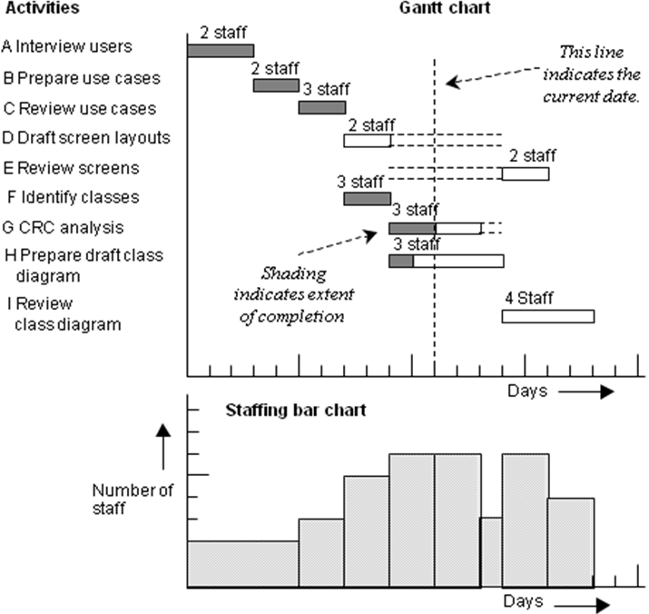
Figure 22.6 Gantt chart showing activity completion and smoothed staff profile.

When a critical path activity is behind schedule it may not be possible to regain the lost time by making additional resources available. A project manager then has two main options, and the choice and its financial or other consequences should be discussed with the client: either the project deadline can be moved to accommodate the delay; or the scope of the project or the quality of the product can be reduced to permit completion on time. The last approach requires an analysis of all uncompleted critical path activities in order to identify what can be omitted to reduce their ED’s. The resultant changes may alter the critical path, and activities whose completion was not critical before may now become critical. Any attempt to reduce the scope of a project requires user involvement to ensure that only non-critical features are omitted, particularly during the first increment.
The process of planning a project is iterative. An alteration to the staff allocation for an activity will probably change its ED, which in turn may change the critical path. A project manager must operate within the constraints of staff and resource availability.

22.3 PRINCE2
PRINCE2 (Projects In Controlled Environments) has become the de facto standard project management methodology in UK and is used widely around the world. PRINCE was launched in 1989 by the then Central Computer and Telecommunications Agency (CCTA) which has subsequently been renamed the Office of Government and Commerce (OGC). The revised version, PRINCE2, was released in 1996 and is in the public domain with the copyright being held by the OGC.
PRINCE2 provides a process model for project management and identifies specific roles and management structures that should be put in place. A PRINCE2 project has a defined and finite life cycle; it should produce measurable and defined products through a series of activities. It will have specified resources and an organisational structure for its management.

For each PRINCE2 project a set of roles are specified:
- a Project Manager who organises and controls the project should be nominated;
- the Customer or Executive is the person who is paying for the project;
- the User is the person who will use the outcome of the project and may be the same person as the customer;
- the Supplier or Specialist who does the work to complete the project.

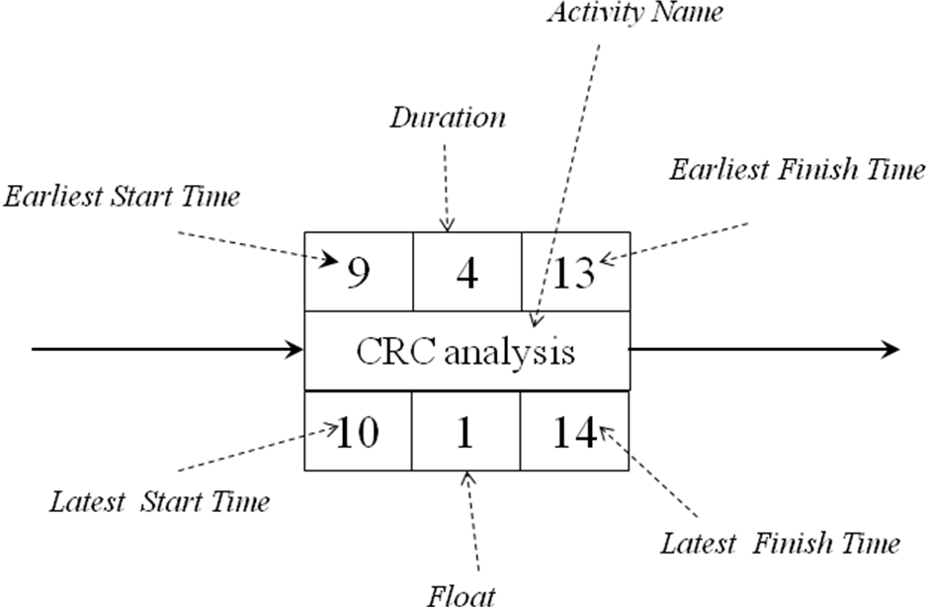
Figure 22.7 PRINCE2 : An activity from planning network

The PRINCE2 methodology does not cover all aspects of project management. For example, it does not specify the planning techniques to be used nor the risk management approach to be adopted. The way quality management and assurance should be performed and how budgetary analysis should be conducted are also left for the project team to determine. In many organisations there will be an agreed approach to project management that will guide these decisions. However, PRINCE2 does provide a clear framework for the conduct and management of the project with a strong emphasis on project deliverables.
Each PRINCE2 project is controlled by a Project Board. The project board comprises representatives from the customer, user and supplier groups. The project manager reports progress to the project board and identifies possible problems. The project board makes the decisions to direct the conduct of the project.
An inherent part of project planning is scheduling tasks and this can be performed by producing a planning network. Figure 22.7 shows a notation for an activity using the ‘activity on the node’. Figure 22.8 shows a planning network that could be used on a PRINCE2 project. This planning network is based on the project activity table in Figure 22.1 and is equivalent to the CPA chart in Figure 22.4. It should be noted that the diagram in Figure 22.8 does not need dummy activities to show the sequence of activities and the critical path is shown by the red arrows. Each activity on the critical path has a float of zero. This style of notation is widely used.

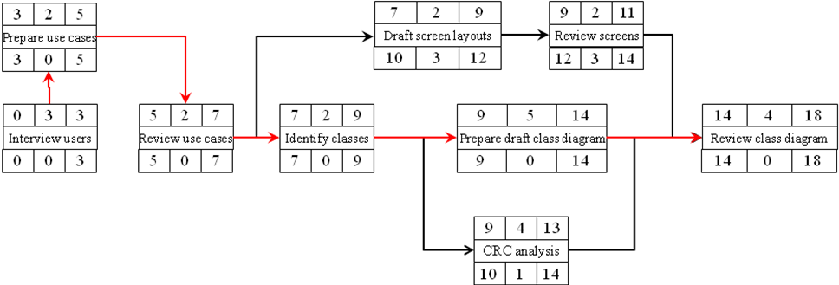
Figure 22.8 PRINCE2 : A planning network

22.4 Managing Iteration
In Chapter 3 we considered prototyping as an iterative development activity and discussed the need to specify objectives for the prototyping activity so that they can provide criteria to control the number of iterations (Figure 3.6 shows an example of an iterative life cycle). At the end of an iteration the product, say a prototype, is evaluated against pre-defined objectives. In general terms this seems straightforward but in practice it can be difficult to determine whether the objectives of the iterative activity have been achieved.
Let us suppose that the interface for the Agate Campaign Management system is to be developed by prototyping, with the explicit objective of producing an interface with which the campaign staff are happy. However, although this objective may be worthwhile it is of little use for the management of the activity. Imagine that the users are never completely happy at the end of any iteration: they will continue to suggest further improvements without end. As the process continues, the nature of the modifications that are suggested at each iteration will change. Over time the improvements will become cosmetic and ultimately peripheral to the utility of the system. It would be sensible to end the iterative process before this point is reached. A more suitable objective for the exercise might be phrased as follows:
Figure 22.8 PRINCE2 : A planning network

Continue the iterations until fewer than five cosmetic changes are requested on a single iteration.
It is still not clear how many iterations will be needed to satisfy this criterion. If the project has unlimited time and an unlimited budget this may not be a problem but this is unlikely to be the case. Additional criteria can be added to tighten up the objectives, such as the following.
The prototyping phase must be completed before the end of October and must not exceed 50 developer-hours.

Timeboxing (see Chapter 21) is an effective way of managing iterations within a project. It limits the amount of resource that is available and, assuming that there is effective user participation in the development team, it focuses on the most critical requirements.

22.5 Issues for O–O Project Management
Some authors (Nessi, 1998) have identified differences between the project management of object-oriented information systems and project management of information systems using other technologies. Cockburn (1998) has also identified differences in project management but suggests that managing object development projects is largely the same as managing non-object development projects. The differences arise for several reasons including:

- different project lifecycles (See Chapters 3 and 21)
- viewing analysis and design as activities rather project stages
- the use of the many of same modelling techniques during different project stages in object-oriented development, so-called ‘seamless’ development
- the use of new implementation technologies
- the move to component-based development
- the integration with heritage systems (see Sections 13.4.1 and 22.7).

Approaches to deal with these differences can be seen as appropriate for the management of any project where new technologies and ways of working are introduced. For example it is key that development staff are suitable trained in the use of the development technologies that they will be using. As Cockburn (1998) suggests it would be foolhardy in the extreme to ask developers to embark on a large and expensive development project without the necessary training. Generally where new technologies and approaches are being used it is wise to ensure that the project team have the support of a mentor who is experienced in the technologies being used.
When any project is initiated it is important to assess the risks that may exist and develop approaches to manage them (Field and Keller, 1998). These will include risk avoidance, risk reduction and contingency planning. Where new technologies are being used, perhaps in novel or unfamiliar ways, there are potentially a host of risks associated. The technology may not work as expected, it may not integrate with existing systems or it may take longer to develop parts of the system than anticipated. Where these possible risks are identified the project plan should be adjusted to ensure that they are managed effectively. For example, it may be appropriate to develop a prototype using the new technology to demonstrate that it will work as expected or to ensure that it will integrate with existing systems. Such prototypes should be developed early in project. Alternatively, if prototyping is not appropriate, the development of increments with significant risks should be scheduled early in the project as this may make it easier to mitigate the risks. An iterative approach to development enables the development team to learn from early iterations and adjust their development approach for later iterations. In particular, time estimates for tasks should be refined in the light of the experience gained. The project manager then has to determine whether the project can be completed on schedule and if not negotiate with the customer whether additional resource is made available or whether the project objectives are to be reduced.

22.6 Software Metrics
Planning and managing a software development project requires the estimation of the resources required for each of its constituent activities. A resource estimate for an activity can be based upon subjective perceptions of the activity or it can be based upon measurements of size and complexity, either of the activity itself or of the artefact that is produced. DeMarco (1982) suggested that in order to control and manage an activity it should be monitored and measured.
We are used to applying measures in many forms of human endeavour. For example, the productivity of a car factory can be measured quite accurately in terms of the time taken to construct a car. The use of metrics in software development is still rather limited. The term software engineering was coined in the 1960s as part of an attempt to introduce the greater degree of rigour that was seen in the management of other types of engineering. It is a feature of most engineering disciplines that careful measurement is used to assess the efficiency and effectiveness of artefacts and of processes. A software metric is a measure of some aspect of software development, either at project level—usually its cost or its duration—or at the level of the application—typically its size or its complexity.
Software metrics can be divided broadly into two categories: process metrics that measure some aspect of the development process and product metrics that measure some aspect of the software product. (We use the term software product broadly to include anything that is produced during a software development project, including for example analysis models and test plans as well as program code.) Two examples of process metrics are the project cost to date and the amount of time spent so far on the project. Product metrics relate to the information system that is under development. One of the simplest product metrics is the number of classes in an analysis class diagram.
Software metrics can also be categorized as result or predictor metrics, which are used respectively to measure outcomes and to quantify estimates. The current cost of a project is a result metric (even though this is only an interim outcome that will probably be modified tomorrow). A measure of class size (a crude measure might be a simple count of attributes and operations) would be a predictor metric, so called because it can be used as a basis for predicting the time that it will take to produce program code for that class. Result metrics are also known as control metrics (Sommerville, 2007) since they are used to determine how management control should be exercised. For example, a measurement of the current level of progress in the project is used to decide whether action is necessary to bring the project back onto schedule. The term ‘predictor metric’ is generally applied only to a measure of some aspect of a software product that is used to predict some other aspect of the product or of the project progress. Predictor metrics are not used solely for estimation. The results obtained from their application to a project may indicate, for example, that the system will be difficult to maintain or that it may offer very low levels of reuse. Since neither outcome is desirable, managers may attempt to change the design for the system or the process for its development in order to improve the system.
The validity of predictor metrics is based upon three assumptions, often made only tacitly by managers (Sommerville, 2007):

- there is some aspect of a software product that can be accurately measured
- there is a relationship between the measurable aspect and some other relevant characteristics of the product
- this relationship has been validated and can be expressed in a model or a formula.

The last of these assumptions suggests that a significant volume of historical data must be collected so that an appropriate statistical analysis can validate the relationship. In practice this is only feasible if the data collection is automated (for example, it is done by a CASE tool). Generally speaking, software developers do not regard the capture of metrics data as an important part of their role. Their attention is inevitably focused on the delivery of the product on time. Another factor that limits the uptake of metrics is the possibility of using them to monitor the performance of the developers themselves. This may give rise to concern among the developers about how data on their performance might be used. This is of course an ethical issue as well as a management one.
A number of metrics have been identified for use with structured analysis and design approaches. For example, De Marco (1982) developed a complexity metric known as the Bang Metric for use on structured analysis projects. Other metrics that focused on the degree of coupling and cohesion between program modules have also been suggested for use with a structured design approach. Most of these metrics were used little despite the introduction of automated CASE support.

A number of authors have identified metrics for object-oriented systems development (Lorenz, 1994; de Champeaux, 1997; Graham, 1995). De Champeaux suggests a list of desirable features as part of a general description of a useful metric:

- either it is elementary and focuses on a single well-defined aspect, or it is an aggregation of elementary metrics
- it is suitable for automated evaluation
- gathering the metric data is not too costly
- it is intuitive
- application to a composite is equivalent to application to the components and summation of the individual results
- the metric can be measured numerically and arithmetic operations are meaningful.

de Champeaux (1997) lists a series of quality metrics, for example, a dependency metric that provides a measure of the stability of a system. When applied to a package or a sub-system this measures the degree of inter-package or inter-sub-system coupling. It is calculated by the formula:
I = Ce
(Ca + Ce)
where I is the instability of the system, Ca is the level of afferent coupling (the number of classes outside the package that depend on classes within the package), and Ce is the level of efferent coupling (the number of classes outside the package upon which classes within the package depend) (adapted from de Champeaux, 1997).
When I is zero the package is maximally stable and has no dependencies on classes in other packages. When I is 1 the package is maximally unstable and has dependencies only on classes outside itself.
The ability of a package to absorb change is reflected (in part at least) by the ratio of abstract classes to all classes within the package. Where this is zero then the package consists solely of concrete classes and is difficult to change. A ratio of one indicates the presence of no concrete classes at all and it is easier to change.
Lorenz and Kidd (1994) suggest a wide range of metrics including metrics for application size and class size. Application size is essentially determined from the number of use cases and the number of domain classes together with multiplying factors that reflect the complexity of the user interface. The size of a class is determined by the number of attributes and operations it has and the size of the operations. Size metrics such as this can be used to estimate the resource requirement for a project providing that appropriate historical data is available to derive and validate the relationship.

22.7 Process Patterns
We have already discussed analysis patterns in Chapter 8 and design patterns in Chapter 15. Coplien (1995) has defined a pattern language that is focused on the development process. The pattern language comprises both organization and process patterns. As with design patterns they capture elements of experience as problem–solution pairs. The patterns address issues such as team selection, organizational size, team structure, the roles of team members and so on. Conway’s Law (Pattern 14) discusses how the architecture of the system comes to reflect the organizational structure or vice versa. Mercenary Analyst (Pattern 23) is concerned with producing project documentation successfully. This pattern suggests that it is frequently more effective to hire a technical writer who can focus solely on the documentation.

22.8 Heritage Systems
There are many definitions of the term heritage system. We take it to mean any computerized information system that has been in use for some time, that was built with older technologies (perhaps using a different development approach at different times) and, most importantly, that continues to deliver benefit to the organization. Most computerized information systems interact with other computerized information systems. They may share data, the output from one may be an input to another and so on. Any new information system is likely to need to interact with older heritage systems that have not been built using the same technologies. Redeveloping heritage systems so that they interact appropriately with new systems is likely to be prohibitively expensive and probably involves too much risk. These heritage systems may be critical to the operation of the organization. The problem is one of integrating new object-oriented systems with non-object-oriented systems.
One strategy that enables the interoperation of old and new is the use of an object wrapper (Graham, 1995). An object wrapper functions as an interface that surrounds a non-object-oriented system so that it presents an interface suitable for use with new object-oriented systems. Essentially the old system appears to be object-oriented. The form of the wrapper depends on the nature of the heritage system. Where the old system uses text or form-based screen interfaces the wrapper may involve program code that reads data from the screen and writes data to the screen (sometimes known as screen scrapers) using some form of virtual terminal.

When an organization embarks upon object-oriented software development there may be an intention to migrate all existing software to the new technologies. The cost and risk involved may constrain this but where it is feasible to migrate systems it is important to manage the process carefully. Wrappers may be used initially to provide an object-oriented interface to the system. Then, once the system has been wrapped, it can be redeveloped (perhaps one sub-system at a time) without affecting its interface to other systems. A further variation on this approach is to use the Facade pattern (see Chapter 20) to wrap sub-systems so that they can be migrated incrementally.

22.9 Introducing Object Technology

The introduction of any new way of working requires careful planning. Introducing object technology is a very significant change. Both the approach to systems development and the development technology are new. Staff must be trained in the principles of object-orientation, in new analysis and design techniques, in one or more object-oriented programming languages, in the use of new development environments and perhaps also in how to use a particular object-oriented database management system. Almost every aspect of the software development activity will change. This is not just a matter of training the developers; they also must gain experience in applying the new techniques and using the new technology. The safest way to achieve this is to apply object-orientation within a pilot project in the first instance (as suggested for FoodCo in Box B1.2). The move to object-orientation must be carefully planned and controlled and should ideally follow the steps shown below:

- identify a suitable pilot project
- train the relevant staff
- monitor the project carefully when it is under way
- review the project implementation
- identify the lessons learned and migrate this experience to other suitable projects.

Identification of a suitable pilot project. A pilot project should ideally not be subject to very tight timescales. The team is likely to require additional time to become familiar with the concepts and notation. The project should be amenable to an object-oriented approach in terms of its application domain and implementation technology.
Training. The move to object-orientation requires a different perspective on the problem domain. Training should be planned so that developers are trained in the new techniques immediately before they need to use them. It is important that a developer should understand the conceptual basis of object-orientation before embarking upon learning a new modelling notation (for example, UML) or a new programming language (for example, Java). Training and familiarization with the selected CASE toolset should be included. Users who will interact with the project should also be trained so that they can participate effectively in user reviews.
Monitoring the project. To gain maximum benefit from the move to object-orientation it is important to monitor its use within the organization. This provides feedback on the effectiveness of the training, the most appropriate way of applying the techniques and the project management requirements.
Review project implementation. A post-implementation review provides an opportunity to determine whether or not the expected benefits of the approach have been realized. It is important not to place unreasonable expectations upon a pilot project since unfulfilled aspirations may then over-shadow its successes. For instance, the potential benefits of reuse are unlikely to be achieved immediately after an organization has migrated to object-orientation. Even with careful management, significant levels of reuse may not appear for a further two or three years.
Migrate experience to other suitable projects. The experience of the pilot project will suggest adjustments that can be made to improve the way that object-orientation is to be used in the organization. Members of the initial project team may be used to seed other projects with their experience of the use of object-oriented development methods.

22.10 Summary
Systems development projects are similar to any other project in their need for sound management to ensure that they are completed within budget and on time. Some standard project management techniques used for this purpose include Critical Path Analysis and Gantt Charts, both of which can be used for project planning, to monitor resource utilization and to monitor project progress.
The successful management of systems development relies on the quantification of various measures of effort, progress and complexity. A number of software metrics have been developed for this purpose including some that are intended specifically for use within object-oriented development.
The introduction of object-orientation to an organization should be carefully planned and managed. It is also important to ensure that existing computerized information systems can continue to operate alongside object-oriented systems, for example by the use of object wrappers.
The success of an information systems development project depends upon many factors, but in the final analysis the most important factor by far is the skill of the development staff. Effective project management enables developers to apply their knowledge and expertise in the most productive way.
When used by suitably skilled developers and managed by appropriately qualified managers, object-oriented development offers a means for capturing, modelling and building complex information systems that fully meet the needs of their users.

Review Questions
22.1 For what areas of software development management did Yourdon think modelling techniques would be useful?
22.2 How do PERT and CPA differ?
22.3 What are the two main styles of notation for CPA charts.
22.4 In CPA how is the slack time for an activity calculated?
22.5 What is meant by the term critical path? In CPA how can you decide whether a milestone is on the critical path?
22.6 Under what circumstances are dummy activities used?
22.7 What is meant by the term resource smoothing?
22.8 What are the advantages of a Gantt chart when compared to a CPA chart?
22.9 What are the advantages of a CPA chart when compared to a Gantt Chart?
22.10 How do object wrappers help integrate new object-oriented systems with existing non-object-oriented systems?
22.11 What factors should be considered when migrating to object technology?

Case Study Work, Exercises and Projects
22.A Prepare a CPA chart, a Gantt chart and a staffing profile for the project activities shown in the following table.

Activity | Description | Mile-  stone | Preceding activities | Expected duration | Staffing
A | Interview users | 2 |  | 4 | 3
B | Prepare use cases | 3 |  | 3 | 2
C | Review use cases | 4 | A, B | 3 | 3
D | Draft screen layouts | 5 | C | 4 | 2
E | Review screens | 6 | D | 2 | 2
F | Identify classes | 7 | E | 2 | 3
G | CRC analysis | 8 | F | 3 | 2
H | Prepare draft class diagram | 9 | F | 4 | 3
I | Review documentation | 10 | G, H | 4 | 4

22.B FoodCo had never used object-oriented development methods until the start of the Production Costing System project. Identify other projects at FoodCo that would be alternative candidates for a pilot project, when considered as the first step in a company-wide migration process. Compare these in terms of their appropriateness.
22.C Critically evaluate a project management software package that is available to you. What changes to its functionality and non-functional characteristics would be required for it to be integrated with a CASE tool that supports UML?

Further Reading
De Marco (1982) provides a good introduction to the issues of managing software projects although the development techniques discussed are not object-oriented.
Graham (1995) examines the migration to object technology and is well worth reading.
Cockburn (1998) contains a useful discussion of the issues arising from managing object oriented projects and Field and Keller (1998) provide a detailed discussion of project management for issues.
There are a wide range of sources of information about PRINCE2 including the Office of Government Commerce (OGC) at http://www.ogc.gov.uk/methods_prince_2.asp. The OGC also offers a range of publications about PRINCE2. Lorenz and Kidd (1994), Graham (1995) and de Champeaux (1997) address the use of object-oriented metrics. Melton (1995) is a collection of research articles on the subject, the first chapter being an interesting history of the development of software metrics. Sommerville (2007) includes a useful discussion on the use of software metrics.
Coplien’s pattern language (Coplien, 1995) describes many interesting patterns that will be familiar to project managers, albeit in many different guises.

Strictly speaking PERT is more elaborate than CPA, using statistical measures in addition to critical path analysis, but the terms are generally used synomously.
Lorenz and Kidd use the terms 'scenario scripts' and 'key classes'.

